Satistics Project

Matt Zlotnik

1. The sales over the past year, when put into a histogram, seem pretty symmetric, with a slight skew to the right. The mean of sales is $1298, while the median is $1275, confirming the slight rightward skew. Over time, it seems the sales seem to fluctuate pretty steadily around the mean, with a few outliers (that will be explained in the next question). The sales over time seems to be approximately linear, with a slight growth over the year.

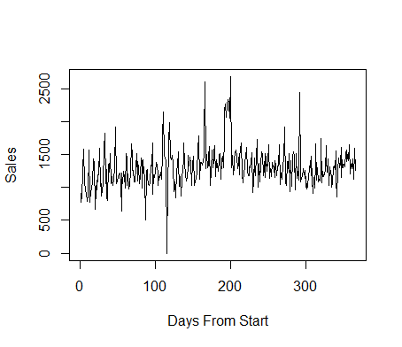

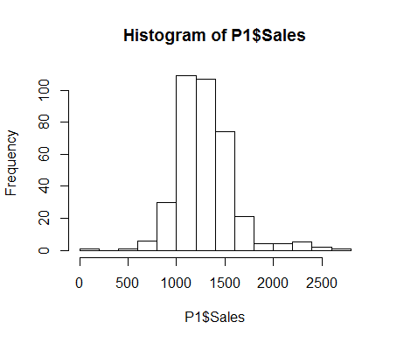

1. There seem to be four total outliers on the graph. Just after 100, the sales are zero. That date happens to be Christmas Eve, which means the shop was most likely closed that day. Another outlier is about ¾ the way between 100 and 200, which happens to be Valentine’s Day. The store must have run some sort of promotion to attract couples on Valentine’s Day, as the store recorded $2595 in sales that day. The other two outliers fell on March 19 and June 18, which are seemingly random days that the store must have run special promotions.